**Split Ship for Surcharge/Freight**

**SDM: 28959**

Requirement Document

Version 1.0

Revision History

|  |  |  |  |
| --- | --- | --- | --- |
| **Date** | **Version** | **Description** | **Author** |
| 04/19/2022 | 1.0 | Initial creation | Cather Cheese |
|  |  |  |  |
|  |  |  |  |
|  |  |  |  |

Contents

1 Introduction 4

1.1 Purpose 4

1.2 Scope 4

1.3 Contributors 4

1.4 Definitions, Acronyms and Abbreviations 4

2 Overview 4

2.1 Current State 4

2.2 Future State Request 4

3 Understanding the User Environment 4

4 Assessing the Opportunity 4

5 Assessing Reliability, Performance, and Support Needs 5

6 Functional Requirements 5

6.1 General Requirements 5

6.2 User Interfaces 5

6.3 Software Interfaces 5

6.4 Hardware Interfaces 5

7 Error Handling 5

8 Questions and Issues 5

9 Risks and Assumptions 5

10 Signoff 5

# Introduction

## Purpose

Gabriella White continues to access ways to handle an overwhelming backlog of orders not “Ready to Ship”. Gabriella White has increased shipping spilt orders to help solve the problem of product sitting in the warehouse.

Currently for Wholesale and Contract sales orders the entire freight and surcharges amount are placed on the first dispatch ticket. Customers are unhappy with been charged upfront when their orders are split over multiple dispatch tickets.

## Scope

The scope of this task is to create a process to place a percentage of the total freight and surcharges based off the items on the dispatch ticket. The process will modify the existing service for adding freight and surcharge on the dispatch tickets. The new process should also handle adding the remaining freight and surcharge back to the sale orders so it will be distributed on the remaining dispatch tickets created. The service should ensure the final dispatch ticket has all the remaining freight and surcharge.

## Contributors

|  |  |
| --- | --- |
| **Resource** | **Department** |
| Justin Pope [JP] | MIS – Software Developer |
| Maureen Minard [MM] | Executive Management - |
| Ben Erickson [BE] | IT – Vice President |
| Elaine Greene-Yancey [EY] | Marketing – Senior Director of Customer Experience |
| Cara Dooley [CD] | Accounting and Finance – Credit/AR manager |
| Patricia Toney [PT] | Accounting and Finance – AR specialist |
| Cather Cheese [CC] | Application Development manager |
| Dawn Hester Guillot | Distribution - Scheduling Analyst |

## Definitions, Acronyms and Abbreviations

|  |  |
| --- | --- |
| **Term** | **Definition** |
| Dispatch Ticket |  |
|  |  |
| Syspro | ERP System |
|  |  |
|  |  |
|  |  |
|  |  |
|  |  |
|  |  |
|  |  |

# Overview

This is an overview for Order to Cash Simplification proposal, this document focuses on the changes for surcharges and freight on split orders.

Order is entered into Syspro.

*If Prepaid and Add customer service references the freight map and adds the appropriate percentage.*

*Customer Service uses google maps to determine if the ship to address is commercial or residential and codes appropriately. We are currently looking at a freight calculator and an address validator. Shipper HQ demo (Tom checking into)*

Customer Service acknowledges the order to the customer and changes the status to Suspense.

*Accounting uses the LOS report (Credit approval current) to determine which orders need attention. They open each order. If cc on file, you charge the deposit to the card. If x terms, contact the customer for payment. Already an RFP related to automating cc payments.* Pending factor accounts automatically go the factor and are automatically approved.

All orders over $2,000 will be charged a 50% deposit. All orders under $2,000 will be charged in full at the time of processing. (Pending factor, Net 30 or Net 60 accounts are not charged a deposit.) This will allow for alignment across all business channels including retail, wholesale and contract.

Orders will proceed through normal processes until it is time for them to ship. When an order is ready to ship it will appear on the balance due report (Maureen will check on options to trigger this automatically). *Accounting opens each order and charges the amount needed*. Orders that are shipping complete will be charged in full including all freight charges and the surcharge. *Orders that are split shipping will be charged for the percentage of the order shipping and the corresponding percentage of the total freight charge and surcharge. Example: If we are shipping 70% of the product on an order, we would charge the customer for 70% of the product; 70% of the initial freight charge and 70% of the surcharge. Once invoiced, the order would show that the balance due is for the remaining 30% product; 30% freight and 30% surcharge.* IT, Ops and CS have developed shipping rules to assist in the automation of shipping orders.

## Current State

1. Freight is normally included, but the freight could have been missed, customer service reviews a report to determine if freight was missed.
2. All freight and surcharges attached to a sales order are created on the first dispatch ticket
3. Freight (line type 4) and surcharge (line type 5) are copied over from a SQL trigger on the SysproCompany100.dbo.AdmSignatureLog table.
4. The SORTDM Dispatch Note Maintenance business object is not available in our current version of Syspro. Once we upgrade to V8 we could utilize that if needed.
5. The SORTDA Dispatch Note - Add line from Sales Order does not seem to support adding freight lines from the sales order. It does support adding a freight line to the dispatch but does not allow linking it back to the original sales order line.
6. Freight/Surcharge lines on the sales order do not get flagged when dispatched. They are not marked as complete until the dispatch note is invoiced

**Please note:** This is contrary to how the merchandise lines are updated when dispatched. The result (and occasional error we have) is when an order is dispatched a second time when the previous dispatch has not been invoiced, then freight lines could be duplicated to the subsequent dispatch. Therefore, we should not copy or edit sales order lines for freight or surcharges if that sales order line is linked to an open dispatch note line.

## Future State Request

1. Modifications need to be made to the calculated amount in the reserve value
2. Create a table to store percentage of surcharge by category so we can manipulate the amount. (We may not want to have high surcharges on upholstery because it is domestic). **This task will not be part of this scope.**
3. When a sales order is dispatched determine if the sales order has any remaining items outstanding:
4. Query SORDETAILS using the sales order number where SORDETAILS.LINETYPE = 1 and the sum of SORDETAILS.MSHIPQTY, SORDETAILS.MBACKORDERQTY, and SORDETAIL.QTYRESERVED > 0.
5. If the above statement returns results, then adjust the freight and surcharge lines to reflect an applicable percentage of the dollars number of items on the dispatched tickets then copy that amount to the open freight and/or surcharge lines (ex: Total of freight lines divided by total of stocked lines = freight percentage)

Else,

Copy over any open freight and/or surcharge lines.

* + Use the SORTOI business object to accomplish this process

1. Add lines to the sales order for any remaining freight and/or surcharge balance
   * Prior freight total values – current freight total = new freight value
   * Prior surcharge total values – current surcharge = new freight value
2. Change the process to use a SQL trigger to initiate then create a service to handle the process… WIP Job receipt process can be used as an example.
3. Ability to determine freight should be on the order and add freight when needed to eliminate a manual report review by customer service daily. **This task will not be part of this scope.**
4. The process would only need to look at order where prepaid and add was selected as the shipping instructions in Syspro

# Understanding the User Environment

* Who are the users? Scheduling Analyst, Accounting and Finance
* Which additional applications do you use that we need to interface with?
  + [CD] I don’t have any **additional applications**, just Syspro and any SQL tables, etc. that are linked to the 100 Company Data, but I don’t know if Traffic has Datascope or some similar add-on to Syspro they use. Also, not sure what add-on Reporting Services that we will have linked to Syspro in the future that may use some of this data (BizView, SpreadSheet Server, Tableu, etc.)
* What are your expectations for usability of the product?
  + [CD] **Expectations** is exactly what you outlined – hoping that Accounting (and our future CC Automation) can look at an order and know what to charge when, but ALSO that the freight and surcharge are not being billed / invoiced up front to the customer like it has on split ships, but instead that it calculates the percentage based on the percentage of allocated (ready to ship) product – I think you captured all of that in this document! Thank you!
* What are your expectations for training time?
  + [CD] hoping testing and launching (hands on) will help each of us understand the flow and allow for questions and transfer of knowledge, etc.
* What kinds of hard copy and online documentation do you need?
  + [CD] A document similar to this one (showing how it’s calculating / which fields are involved or data from which tables in the 100 Company Data, etc. - in case something goes down / stops working) would suffice for me

# Assessing the Opportunity

* Who needs this application in your organization?
  + [CD] Accounts Receivable, Scheduling Analysts in Traffic – will benefit the most, so that this is not a “manual” process going forward; and Customer Service if you are able to add the piece with a freight line being added during order entry for “prepaid and add” orders
* How many of these types of users would use the application?
  + [CD] 6 in AR; 2 Scheduling Analysts; over 20 CSRs
* How would you value a successful solution? [CD]
  + less phone calls to Customer Service and Accounting re: freight billing questions
  + no manual manipulation or user errors or forgetting to place (or replace) freight lines on Sales Orders
  + more money collected for inbound freight cost (which is a known issue companywide that we are not recovering our costs as well as we hoped)
  + less credit notes to credit invoices and/or manual manipulation of Sales Orders to appease customer concerns or complaints
  + accurate Sales Order confirmations
  + accurate charging of credit card
  + accurate billing / invoicing

# Assessing Reliability, Performance, and Support Needs

* What are your expectations for reliability?
  + [CD] That the freight line is present on every split shipment and accurately calculating the percentage of what is shipping so that the invoices are correct. Also, if a line item is cancelled; that the freight / surcharge re-calculates for this adjustment.
* What are your expectations for performance?
* Do you have special needs for support? What about maintenance and service access?
  + [CD] Please make sure that this is part of the IT testing prior to future updates to the network and/or Syspro
* What are the security requirements? [CD] No security issues currently

# Functional Requirements

Create a Service to split freight and surcharges on dispatched tickets for split-shipped sales orders

## General Requirements

One-time adjustments to sales orders that already have freight split before changes are implemented, this will affect about 1200 orders

* + Create and run a script to adjust fright up on orders about 5% of orders
  + Create and run a script to add freight to orders 95%

## User Interfaces

1. Modifications need to be made to the calculated amount in the reserve value

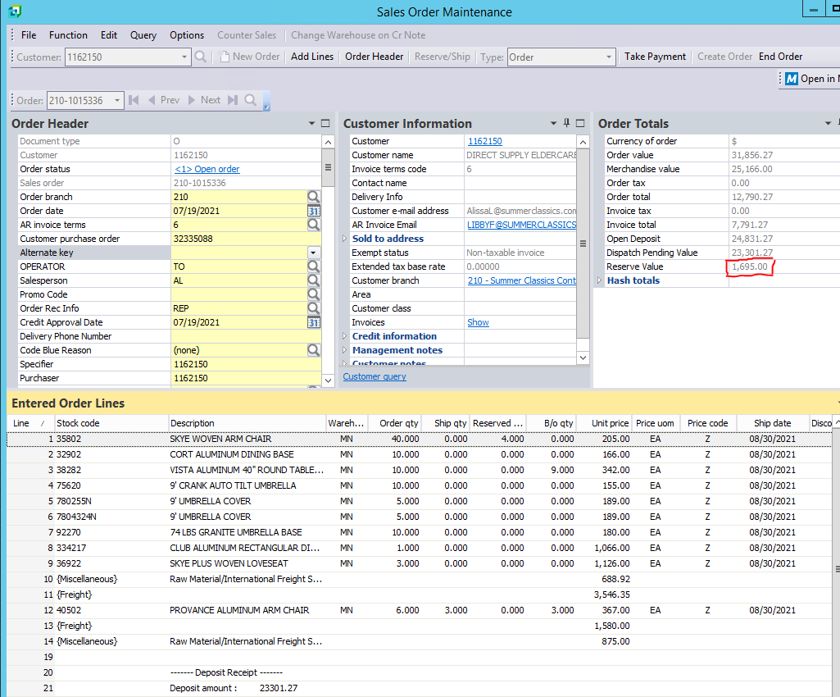  
  
Reserve Value is calculated by the sum of item extended price from quantities in reserve and ship, associated items tax, portion of Surcharges and Freight, associated charges tax, plus extended price of all items and charges on Dispatch Notes that have not been invoice and subtracting deposits on the Sales Order.

Extended Price of Items in reserve and ship:  
 (QtyReserved + MShipQty) * MPrice * (1 + TaxValue)

Portion of Charges:  
 (Extended Price of Reserve and Ship) / (Extended Price of Reserve and Ship + BackOrdered Extended Price)

Surcharge and Freight Price:  
 NMscChargeValue * Portion * (1+TaxValue)

Dispatch Items Extended Price:  
 If LineType = 1  
 TotalValue * (1+TaxValue)  
 If LineType = 4 or 5

NMscChargeValue * (1+TaxValue)

## Software Interfaces

1. When a sales order is dispatched determine if the sales order has any remaining items outstanding:
   1. Query SORDETAILS using the sales order number where SORDETAILS.LINETYPE = 1 and the sum of SORDETAILS.MSHIPQTY, SORDETAILS.MBACKORDERQTY, and SORDETAIL.QTYRESERVED > 0.
2. If the above statement returns results, then adjust the freight and surcharge lines to reflect an applicable percentage of the dollars number of items on the dispatched tickets then copy that amount to the open freight and/or surcharge lines (ex: Total of freight lines divided by total of stocked lines = freight percentage)
   1. Else,
3. SQL Stored Procedure to calculate Charges to dispatch and back order.  
   System Calculations:
   1. System totals the amount that is on back order and that has been dispatched.
      1. Back Order Total:   
         Sum( (MShipQty + MBackOrderQty + QtyReserve) * MPrice ) where SorDetail.LineType = 1
      2. Dispatched Total:  
         Sum( TotalValue ) from MdnDetail
   2. Calculate the Percentages to Dispatch and to Back Order
      1. Dispatch Percentage:  
         Dispatched Total / (Dispatch Total + Back Order Total)
      2. Back Order Percentage:  
         Back Order Total / (Dispatch Total + Back Order Total)
   3. Process Open Charges on Sales Order to be Dispatched
      1. Open Charges  
         NMscInvCharge <> ‘I’  
         and Sales Order Line not linked to a Dispatched Line
      2. Dispatch Value  
         Dipatch Percent * NMscChargeValue rounded up to nearest penny
      3. Back Ordered Value  
         Back Order Percent * NMscChargeValue rounded down to nearest penny
4. Add freight or Surcharge values to Dispatch note based off system calculations
   1. Sql Procedure to add to Dispatch Note
5. Add lines to the sales order for any freight and/or surcharge to Back Order
   1. Use the SORTOI business object to accomplish this process
6. Change the process to use a SQL trigger to initiate then create a service to handle the process… WIP Job receipt process can be used as an example.

## Hardware Interfaces

# Error Handling

# Questions and Issues

1. [CC] Is this process for Retail only orders? This will affect Wholesale and Contract orders
2. [CC] How can we determine if sales order line is linked to an open dispatch note line?
3. [CC]How will we know if the dispatch note is invoiced? Status change once it's been invoiced, this will not affect the changes we are making
4. [CC] What users need to be involved. Dawn Guillot, Carl Dooley, Patrcia Toney, Elaine Green-Yancey

# Risks and Assumptions

# Signoff

Sign-off Signature: ___________________________________ Date:______________